KWAME NKRUMAH UNIVERSITY OF SCIENCE AND TECHNOLOGY

COLLEGE OF ENGINEERING

DEPARTMENT OF CHEMICAL ENGINEERING

TITLE: ELECTRON ABSORBPTION SPECTRA OF SOME Cu (II) COMPLEXES



NAME: SENYO DENNIS A. AKANDE

COURSE: BSC. CHEMICAL ENGINEERING

YEAR: FIRST YEAR

EXPERIMENT NO. : I.1.2.1.

I.D. NO: 1314507

T.A.: ASARE ANYEMEDU
DATE: 12TH APRIL, 2008.

Aims and Objectives:
- To measure the electronic absorption spectra for some complexes of Cu (II) complexes.
- To determine crystal field splitting energies of some Cu (II) complexes.
- To learn to operate the ultra-violet/visible spectrophotometer.
- To improve upon acquired skills for titration.

INTRODUCTION
Transition metals are elements with partially filled d-orbital. Transition metals exhibit a wide range of features which makes them unique and different from other metals on the periodic table. One of such features is the formation of coloured compound. When transition metals absorb energy, they become excited and very unstable; as a result they soon de-excite to release energy in the form of electromagnetic radiations with a particular wavelength. The process of energy absorption, excitation and de-excitation usually occur in the visible region of the electromagnetic spectrum and hence the compounds appear coloured to the eye.

There are several theories that are used to relate electronic absorption spectra to electronic structure. One of these is the Crystal Field Theory (CFT) which relates electronic absorption spectra to electronic structure by giving account for both the colour and magnetic properties of many coordination compounds.

This theory explains the bonding in complex ions purely in terms of electrostatic forces. The d-orbitals have different orientations, but in the absence of external disturbance, they all have the same energy (degenerate). In the presence of these electrostatic field generated by the ligands, the degenerate d-orbitals split between two energy levels: a higher level with two orbitals (d_{x}²_{-y}² and d_{z}²) which form the axial set and represented by the symbol e_{g} and a lower level with three equal energy orbitals (d_{xy}, d_{yz} and d_{xz}) forming the inter-axial set represented by the symbol t_{2g}.
e_{g}

Metal d orbital

t_{2g}

The energy difference between the two sets of d-orbitals is called the crystal splitting energy and is given the symbol Δ₀. The magnitude of ∆° depends on the metal and the nature of the ligands; it has a direct effect on the colour and magnetic properties of complex ions. For an octahedral complex with the electronic configuration of d¹ the ground state configuration is (t_{2g}) ¹.
The electronic absorption spectrum for the complex consist of a single absorption band corresponding to the transition (t_{2g}) ¹→ (e_{g}) ¹. The d9 system is complementary to that of d1. For a given metal ion in an octahedral field, the value of Δ_{o}
depend on the nature of the ligand. Different ligands cause different degrees of splitting of the d orbitals. The list of ligands in order of their capacity to cause d orbital splitting is known as spectrochemical series.
In this experiment, the electronic absorption spectra of some Cu (II) complexes are going to be measured and recorded and their crystal field splitting energies would be determined.

CHEMICALS AND EQUIPMENT
- Ultraviolet Visible spectrophotometer
- An electric burner
- Beakers
- Measuring cylinder
- Volumetric flask
- Fume chamber
- 1 M copper (II) nitrate solution.
- 1 M ammonia solution
- 2 M ammonia solution
- 3 M ammonia solution
- 2 M ammonium nitrate solution
- Concentrated ammonia solution
- Distilled water
- EDTA (ethylenediamine solution)
- Solid glycine

PROCEDURE

a) Preparation of the complexes [Cu (NH₃) _{n} (H₂O) _{6-n}] ²⁺
1) Using a pipette, 1.0 cm³ of the 1 M Cu (NO₃)₂ stock solutions was diluted to 50 cm³ in a volumetric flask. For n=1, 5.0 cm³ of the 1 M Cu(NO₃)₂ solution was pipetted into a small beaker and 14 g of solid ammonium nitrate was added. The solution was stirred and warmed to about 30°C using a stirrer. 5 cm³ of 1 M NH₃ was added and stirring continued until the temperature reached 30°C again. 1 cm³ of the solution was diluted to 25cm³ with 2 M NH₄NO₃ solution.
2) For n=2 and n=3, the same method was used as outlined for n=1 but 1 M NH₃ was replaced with 2 and 3 M NH₃ respectively. For n=4, 1 cm³ of concentrated NH₃ was added to 1 cm³ of 1 M Cu(NO₃)₂ and diluted to 50cm³ with water.

b) Preparation of the complex [Cu (en) ₂(H₂O) ₂]²⁺.
3) 1 cm³ of the 1 M Cu (NO₃)₂ solutions were pipetted into a 50 cm³ volumetric flask. EDTA was added to give a concentration of 0.4 M ethylenediamine solution into a 50 cm³ volumetric flask and made to the mark with distilled water.

c) Preparation of the complex [Cu (gly) ₂(H₂O) ₂]²⁺
4) 1 cm³ of the 1 M Cu (NO₃)₂ solutions was pipetted into a 50 cm³ volumetric flask and solid glycine added to give a concentration of 0.04 M. 20 cm³ of 0.1 M NaOH was added and made to the mark with distilled water.

TABLE OF VALUES

SAMPLE/n | Maximum absorbance | Wavelength at max absorbance/nm | 1/wavelength  (cm⁻¹ ) | ∆◦=(1/wavelength) x 1O⁷ (cm⁻¹) | ∆◦=(1/wavelength) x 1O⁵ (cm⁻¹)
0 | 0.02 | 470 | 2.12766 x 1O⁻³ | 21276.60 | 0.213
1 | 0.04 | 470 | 2.12766 x 1O⁻³ | 21276.60 | 0.213
2 | 0.04 | 680 | 1.47059 x 1O⁻³ | 14705.88 | 0.147
3 | 0.02 | 440 | 2.27272 x 1O⁻³ | 22727.27 | 0.227
4 | 0.03 | 520 | 1.92308 x 1O⁻³ | 19230.77 | 0.192
Cu(en)2(H2O)2 | 0.49 | 680 | 1.47059 x 1O⁻³ | 14705.88 | 0.147
Cu(gly)2(H2O)2 | 0.24 | 680 | 1.47059 x 1O⁻³ | 14705.88 | 0.147

- Glycine, ethylenediamine, NH₃ ,H₂O
Decreasing order of crystal splitting energy

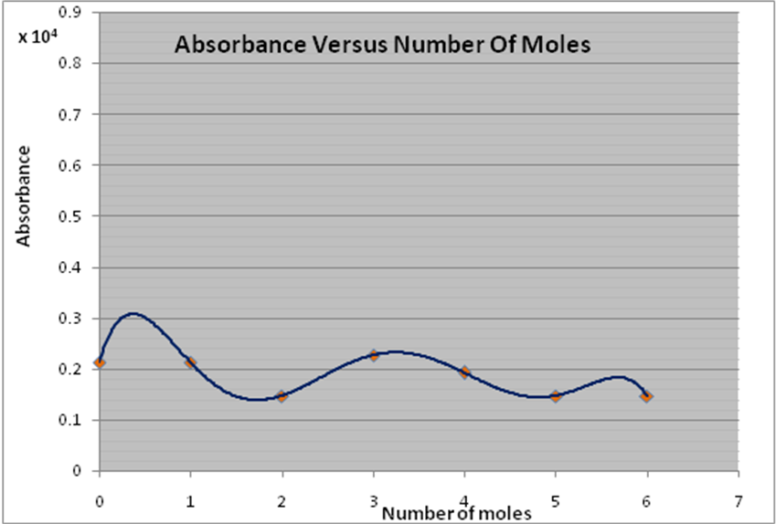

DISCUSSION
Different metal have different crystal splitting energies and the magnitude of this energy depends largely on the nature of the metal and ligands surrounding it. The experiment however employed only Cu(II) complexes, hence the crystal field splitting energy will depend only on the nature and concentration of ligands present in the complex.

When we study the graph critically, we would realize that the highest energies were recorded was for experiment n=0 and 1 (i.e. 0.213 x 10⁵ cm⁻¹ and 0.213 x 10⁵ cm⁻¹ respectively). 2 or 3 M of the NH₃ ligand was added in each case. For the other cases, only 1M NH₃ no ligand was added to the complexes and this resulted in the low magnitude of the energy recorded.

The least magnitude of the crystal field splitting energy was recorded for glycine and ethylenediamine, these complexes are also organic compounds and they hardly form coordinate bonds with negatively charged ligands such as NH₃, as a result, their crystal field splitting energy depends solely on their nature (i.e. their stability). The crystal field splitting energy of ethylenediamine was greater than that of glycine, hence it can be said that the ethylenediamine is more stable than the glycine.
It can also be observed that the graph was somehow sinusoidal, but it did not follow any particular trend. This unusual observation may be due to some errors incurred during course of the experiment.

PRECAUTIONS
- It was ensured that the apparatus was washed with distilled water before use.
- It was ensured that all volumes were read from the meniscus to reduce error by parallax.
- It was ensured that the spectrophotometer was zeroed before taking measurements.
- It was ensured that the solutions were handled with care to avoid solution spillage on the tables

CONCLUSION
From the experiment, it can be concluded that the crystal splitting energy of some copper complexes increased with increasing concentration and number of NH₃ ligands present in the complex structure. Therefore for a group of similar complex species, the crystal field splitting energy depends largely on the concentration and the number of ligands present in the species.
The crystal splitting energy of ethylenediamine is greater than that of glycine, hence ethylenediamine is more stable than glycine. Hence the crystal field theory is an effective theory that can be used to examine how the negative charges on ligands affects the energy of the complex and hence how they split the d-orbital.

Therefore for a group of dissimilar complex species, the crystal field splitting energy depends on both the nature of the complex and the number of ligands present in the complex structure.
The aims of the experiment are thus achieved.

REFERENCES
Modern Inorganic Chemistry, Second Edition by William L. Jolly, pages 357 and 468.
Concise Inorganic Chemistry, Fifth Edition by J.D Lee pages 202-204 and 951.

